2.36: a) The truck’s position as a function of time is given by x_{T} = v_{T}t, with v_{T} being the truck’s constant speed, and the car’s position is given by x_{C} = (1/2) a_{C}t². Equating the two expressions and dividing by a factor of t (this reflects the fact that the car and the truck are at the same place at t = 0) and solving for t yields
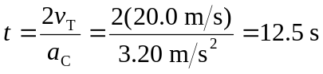
and at this time
x_{T} = x_{C} = 250 m.

b) a_{C}t = (3.20 m/s²)(12.5 s) = 40.0 m/s (See Exercise 2.37 for a discussion of why the car’s speed at this time is twice the truck’s speed.)
c)
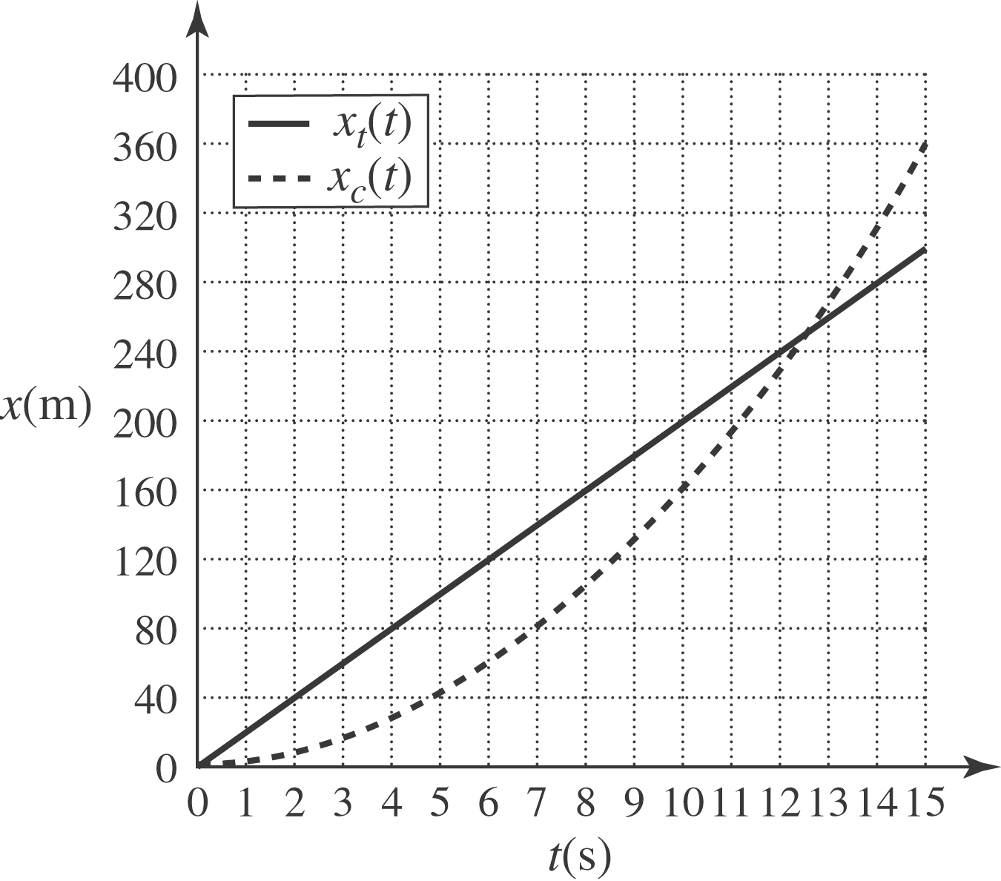

d)
